**Assignment 6**

**OVER and PARTITION BY Clause in SQL Queries and Total Aggregations using SQL Queries.**

**All the aggregation functions can be used with partition by and over clause here I have Used partition by with SUM() and MAX() for examples:**

* **Executing Over and Partition by using Sum()**

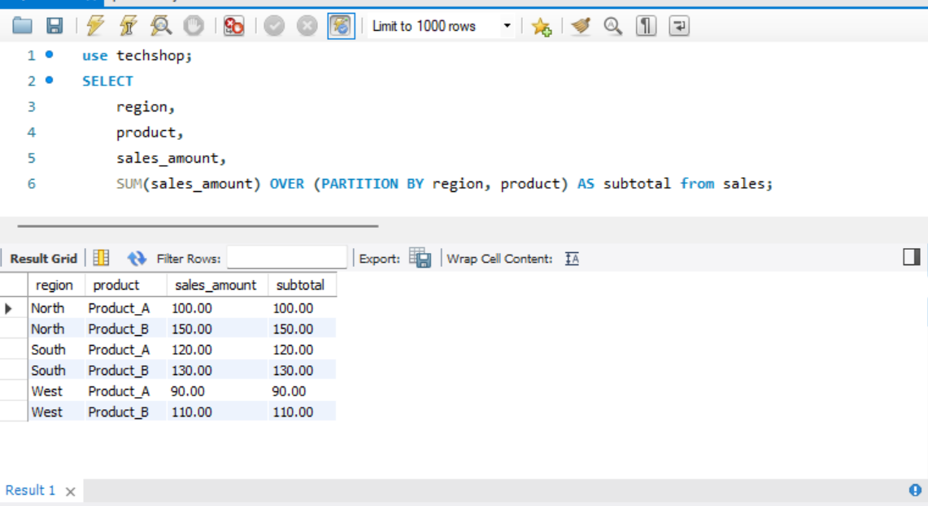

* **Executing Over and Partition by using Max() and Order BY**

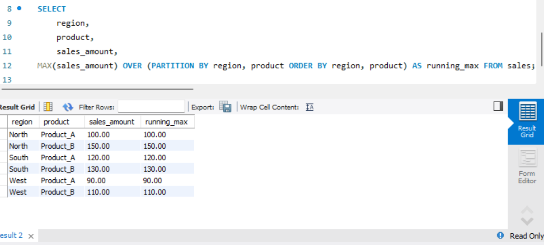

**Snowflake and Star schemas**

Snowflake and star schemas are two common types of database schema designs used in data warehousing to organize and structure data for efficient querying and reporting. Both schemas are related to the concept of a data warehouse, where large volumes of data from different sources are stored, integrated, and optimized for analytical processing.

There are two types of tables:

* Fact Tables: They contain quantitative data.
* Dimension Tables: They Contain descriptive information.

**Snowflake Schema:** Snowflake Schema is also the type of multidimensional model which is used for [data warehouse](https://www.geeksforgeeks.org/data-warehousing/). In snowflake schema, The fact tables, dimension tables as well as sub dimension tables are contained. This schema forms a snowflake with fact tables, dimension tables as well as sub-dimension tables.

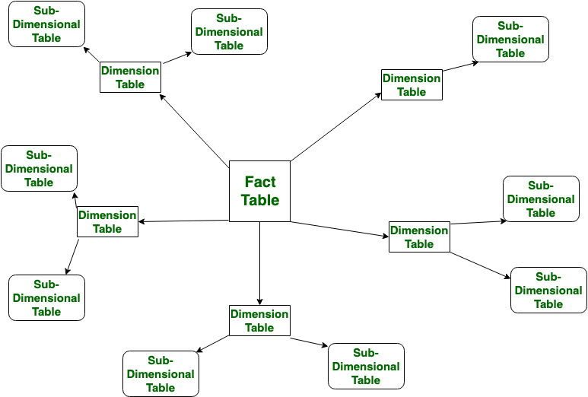

**Star Schema**: Star schema is the type of multidimensional model which is used for data warehouse. In star schema, The fact tables and the dimension tables are contained. In this schema fewer foreign-key join is used. This schema forms a star with fact table and dimension tables.

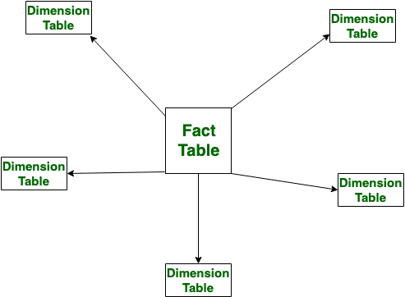

**Order of execution of SQL queries**

Let’s Understand it with example, here is an SQL Query:

**SELECT region, AVG(amount) AS average_amount**

**FROM sales**

**WHERE date >= '2022-01-01' AND date <= '2022-12-31'**

**GROUP BY region**

**HAVING AVG(amount) > 1000**

**ORDER BY average_amount DESC**

**LIMIT 5;**

Now let’s see it’s order of execution:

* **From Clause:**

Identify the table from which data needs to be retrieve (sales table).

* **Where Clause:**

Filter rows based on the conditions specified in the where clause (date >= '2022-01-01' AND date <= '2022-12-31')

* **Group by Clause:**

Group the filtered rows based on the specified column (region)

* **Having Clause:**

Apply a filter to the groups based on aggregate conditions(**AVG(amount) >1000)**

* **Select Clause:**

Specify the columns to be included in the result set (

* **Order By Clause:**

Sort the result set based on the specified column (average_amount DESC), arranging groups in descending order of average amount.

* **Limit/OFFSET or FETCH:**

Limit the number of rows returned to the top 5 (Limit 5).

**How to calculate subtotals in SQL queries**

Calculating subtotals in SQL queries is often done using the Group by clause along with aggregate functions. Here's an example to illustrate how to calculate subtotals:

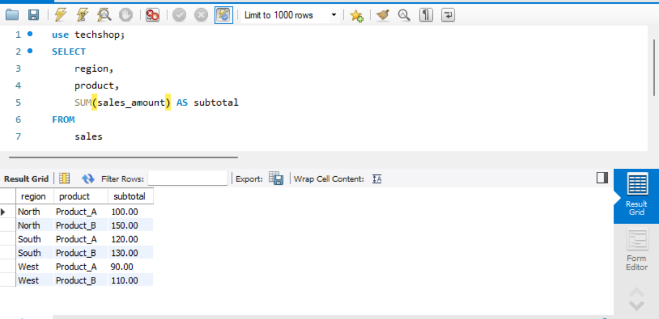

**Difference between union, except and intersect**

* **Union:**

The Union Operator combines the result sets of two or more select queries into a sinle result set and removes all the duplicate values.

* **Except(Minus):**

The Minus operator returns the rows that are present in the first SELECT query but not in the second SELECT query.

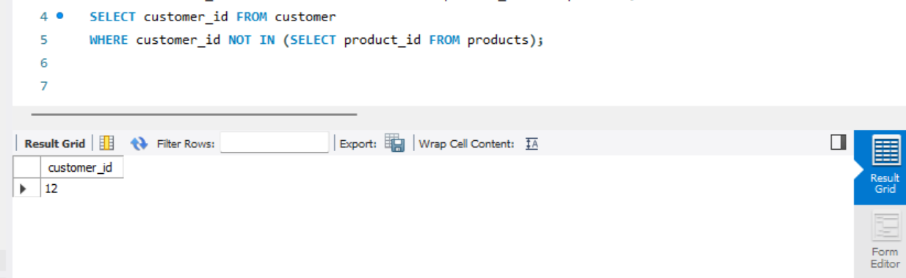

* **Intersect:**

The Intersect operator returns the common rows that are present in both SELECT queries.

**REGEX**

In SQL, regular expressions are used for pattern matching within strings. They allow you to search for and match patterns of characters in text data.

Here are some common SQL functions that involve regular expressions:

**1.LIKE Operator:** The LIKE operator is often used for simple pattern matching.

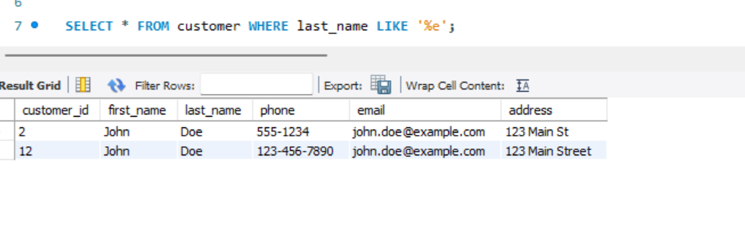

**2.REGEXP Operator:** Some databases, like MySQL and PostgreSQL, support the REGEXP or ~ operator for more advanced pattern matching.

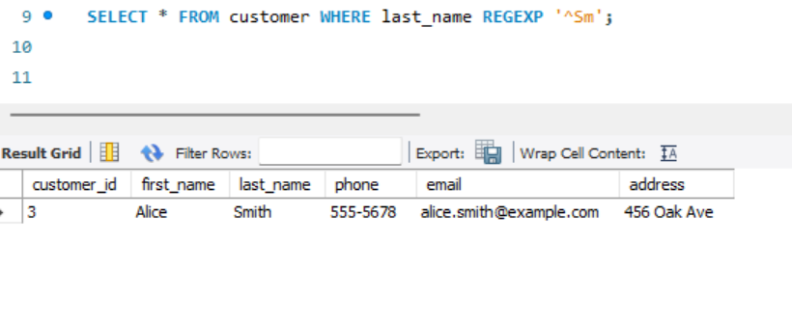

**3.REGEXP_LIKE Function:** Oracle has a REGEXP_LIKE function for regular expression matching.

**4.REGEXP_REPLACE Function:** This function is used to replace substrings that match a regular expression with a specified replacement string.

**5.REGEXP_SUBSTR Function:** This function extracts substrings based on a regular expression pattern.

